Unit 7
Topic:
- News

Eight workers killed in bus accident
Eight workers, five men and three women, were killed and many others injured when a speeding bus overturned in Si Racha district of Chon Buri province late last night.
Pol Lt-Col Krit Khamsathien, the duty officer of Bowin police station in Si Racha, said the bus was taking a number of workers of Auto Alliance (Thailand) Co, an auto manufacturing firm, to a factory in the Eastern Seaboard Industrial Estate in Pluak Daeng district of Rayong province for a night shift.
The bus overturned on the road near a village in tambon Bowin. Five men and one woman were initially found dead in the vehicle and about 40 injured were taken by rescue workers to nearby hospitals in Si Racha, Ban Bung and Pluak Daeng districts.
Two other women died on the way to hospital.
The driver of the bus, which belonged to Khun Anant Co, fled the scene.
Survivors told police the bus was travelling at a very high speed. While overtaking a van the driver lost control of the bus which overturned and rammed into a tree, causing many deaths and injuries.

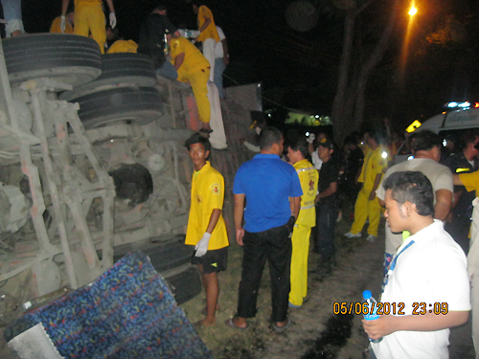

Louis Vuitton introduces Siam Paragon shop
After almost three decades of healthy business performance in Thailand, Louis Vuitton, the French luxury brand, will continue to open new stores here and upgrade other facilities.
Jean-Baptiste Debains, president of Louis Vuitton Asia Pacific, said the fashion house is confident in the potential of Thailand as one of the world's best tourist destinations.
It has four shops here. The first branch was opened in the Mandarin Oriental Hotel in 1985, the second in The Emporium mall in 1997 and the third in Gaysorn Plaza in 2005.
The fourth store with 320 square metres of space opened yesterday in Siam Paragon. It will target younger customers and tourists.
Rachaya Veerapong, the general manager for Louis Vuitton Thailand and Vietnam, said Thailand ranks in the top 20 for spending on Louis Vuitton products and is among the top three in Southeast Asia along with Singapore and Malaysia.
Mr Debains said the brand will increase existing stores to present more product lines from bags, shoes, watches and ready-to-wear fashion.
Despite the debt crisis, it opened two new stores in Italy and Greece.
"No matter whether the economy is good or bad, customers buy Louis Vuitton, because it's an investment," he said.

Rafting competition in Prachin Buri

Benjarong Don Kai Dee Village in Samut Sakhon produces a kind of traditional Thai porcelain called benjarong.
One of Prachin Buri's major tourist spots, Kaeng Hin Ploeng, is open to those with adventurous hearts who will enjoy a variety of activities at the 9th Khao Yai National Park Protection Unit in Na Di district. Rafting through rapids on this stream requires good skills and vigilance. Along the route, well-trained lifeguards are stationed to ensure safety for tourists.
From Aug 17-19, skilled rafting teams are invited to compete in the Rafting Championship of Thailand at Kaeng Hin Ploeng. The competition is divided into two categories: Professional Rubber Rafting (11.5km and 4.5km) for teams of six; and Amateur Rubber Rafting (4.5km) for teams of six.
After the registration on Aug 17, the first round of the professional rafting contest (4.5km) begins at 8am on Aug 18 and the rest of the contests start at 8am on August 19. Applications are being accepted until Aug 17. The entrance fee is 4,000 baht per team.
Apart from Kaeng Hin Ploeng, tourists should not miss Prachin Buri's natural and cultural attractions, such as waterfalls and trekking trails in Prachantakham district and the Chaophraya Abhai-bhubejhr Hospital, where they will see a stunning century-old European-style building and can pamper themselves with traditional massage and holistic medicine.
To get to Kaeng Hin Ploeng, take Road No.33 (Suwannasorn) via Nakhon Nayok, Prachin Buri and Prachantakham, head to Kabin Buri, turn left at the 21km post to Sadoo-Saphan Hin Road, keep going for around 17km, and then turn left at Ban Nong Nae School and continue for another 7km.

Mango with a kick

An exciting young Thai culinary talent showcases the latest flavoured vodka
Chef Sutanit "Deep" Kaewkao from Escoffier (Thailand) has a list of awards that belies her youth. After completing her culinary education at Dusit Thani College, Sutanit went on to win a bronze medal in the team Thai food contest at Asia's first Culinary Cup in 2009. She took the gold medal for her free-style hot dessert at Thailand's International Culinary Cup in 2011, and this year she became the first runner-up in the Young Thai Chef competition held by Escoffier (Thailand).
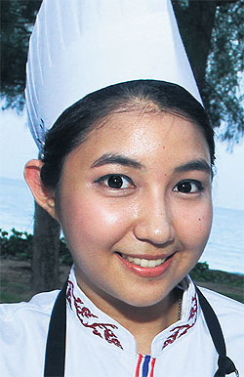
She enjoys making desserts, and her signature dish is chocolate mousse and mango cream cheese tart.
She was guest chef at the recent launch of a new mango-flavoured vodka in Pran Buri. She was excited by the taste of the vodka, and set about creating some dishes that use it.
For the starter, she decided to go with scallops, using the vodka in the dressing, with crisy rice adding a crunchy texture.
For dessert, she came up with a winning combination of mixed nut brownies and fruit cake with vodka sauce.
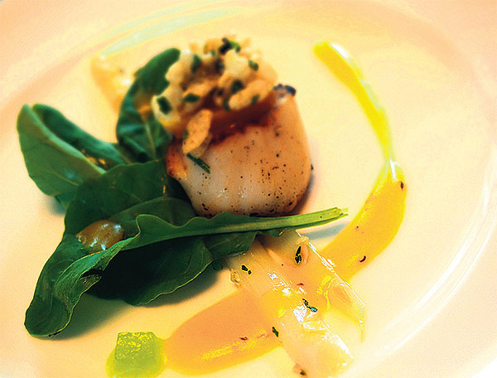

คำศัพท์ Vocabulary
Injured : __________________________
District : __________________________
Province : __________________________
Initially : __________________________
Survivors : __________________________
Decades : __________________________
Performance : __________________________
Luxury : __________________________
Destinations : __________________________
Investment : __________________________
Rapids : __________________________
Stream : __________________________
Require : __________________________
Vigilance : __________________________
Lifeguards : __________________________
Rafting : __________________________
Registration : __________________________
Century-old : __________________________
Themselves : __________________________
Holistic : __________________________
Culinary : __________________________
Scallops : __________________________
Texture : __________________________
Combination : __________________________

